CSCE 5580 COMPUTER NETWORKING

Lab Wireshark TCP

Ganesh Gundekarla

11700551

**Question 01**

IP address of the source is ( aka the client one) : **Source Address: 192.168.1.88**

TCP source port of the client computer is : Source Port: 58937

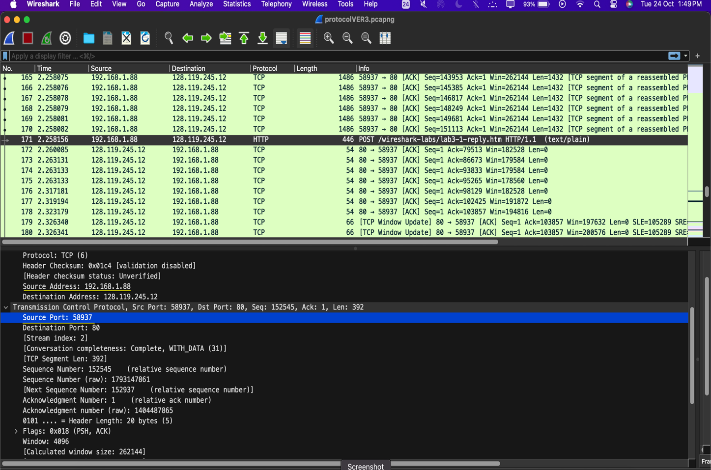

**Question : 2**

**Destination Address: 128.119.245.12**

**Destination Port: 80**

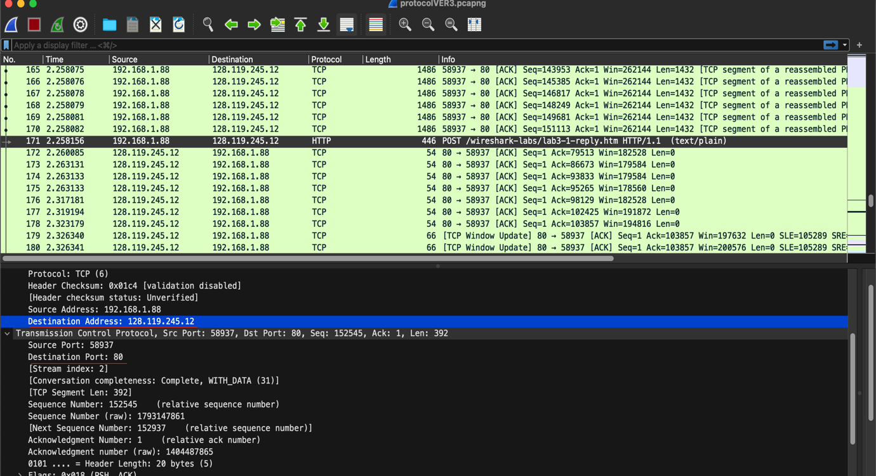

**Question : 3**

I was able to create my own trace and solutions for all questions

My IP address source is : Source Address: 192.168.1.88

sending on port no : Source Port: 58937

Destination address : Destination Address: 128.119.245.12

Receiver side port no : Destination Port: 80



**Question: 04**

What is the sequence number of the TCP SYN segment that is used to initiate the TCP connection between the client computer and gaia.cs.umass.edu? What is it in the segment that identifies the segment as a SYN segment?

Here the frame num: 40 initiates the connection with the client computer and the gaia.cs.umass.edu , so that is set up with a seq number with 0

Sequence Number : 0 (relative sequence number) , Sequence Number (raw): 1792995316

Flags: 0x002 (SYN) identifies the segment as SYN segment and you can see in the below picture only the Syn: Set is turned on.

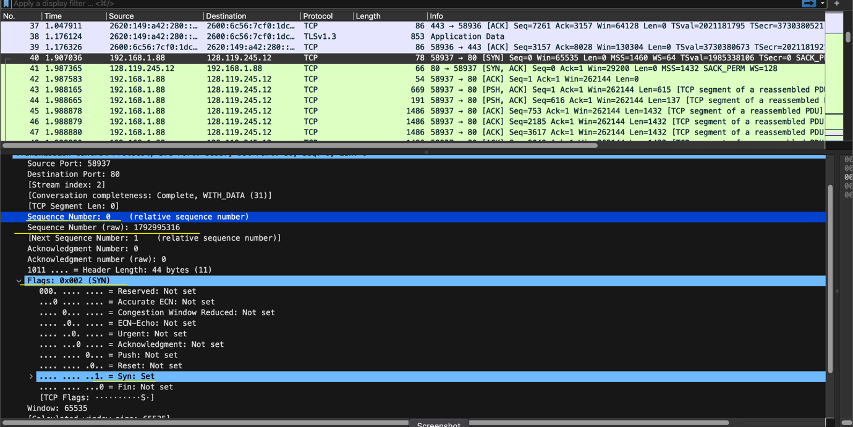

Question-5:

**SynAck** is arriving from port 80(destination) to client’s computer.

1. **Sequence Number(relative one) = 0 Sequence Number (raw): 1404487864**
2. **Acknowledgment Number: 1 (relative ack number),** **Acknowledgment number (raw): 1792995317**
3. **Basically determined by the [initial seq number +1]**
4. Identified using the Flags
5. **Flags: 0x012 (SYN, ACK) ,** this indicates that the flag is set to **SYNACK** and these are turned on in the flags section .
6. **Acknowledgement : Set**
7. **Syn : Set**

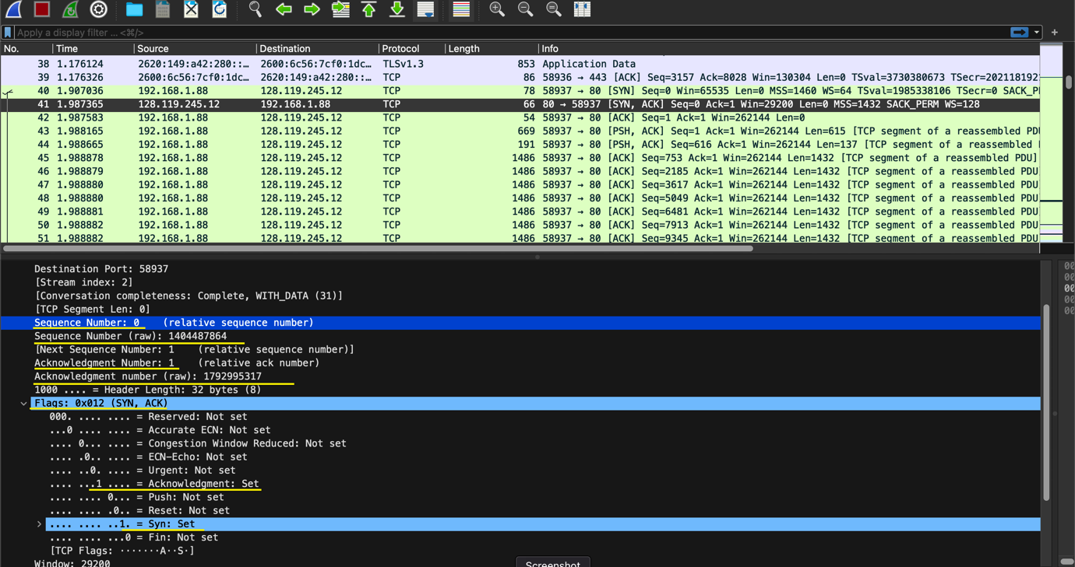

Question : 6

Sequence number of the TCP segment containing the HTTP Post command is

Sequence Number: 1 (relative sequence number); Sequence Number (raw): 1792995317

In the below screenshot we can see the “post” in its data field.

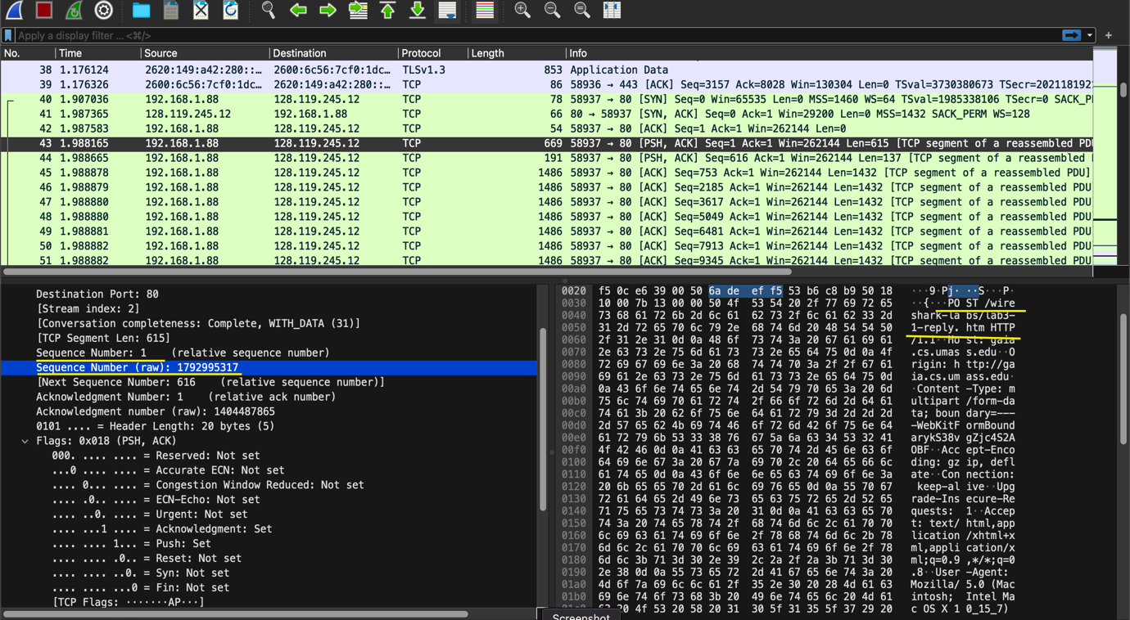

Question : 7

The first ACK sent by the server to the client computer is in frame no 41

The ‘maximum segment size’ in the first ACK by the “server” is 1432 bytes.

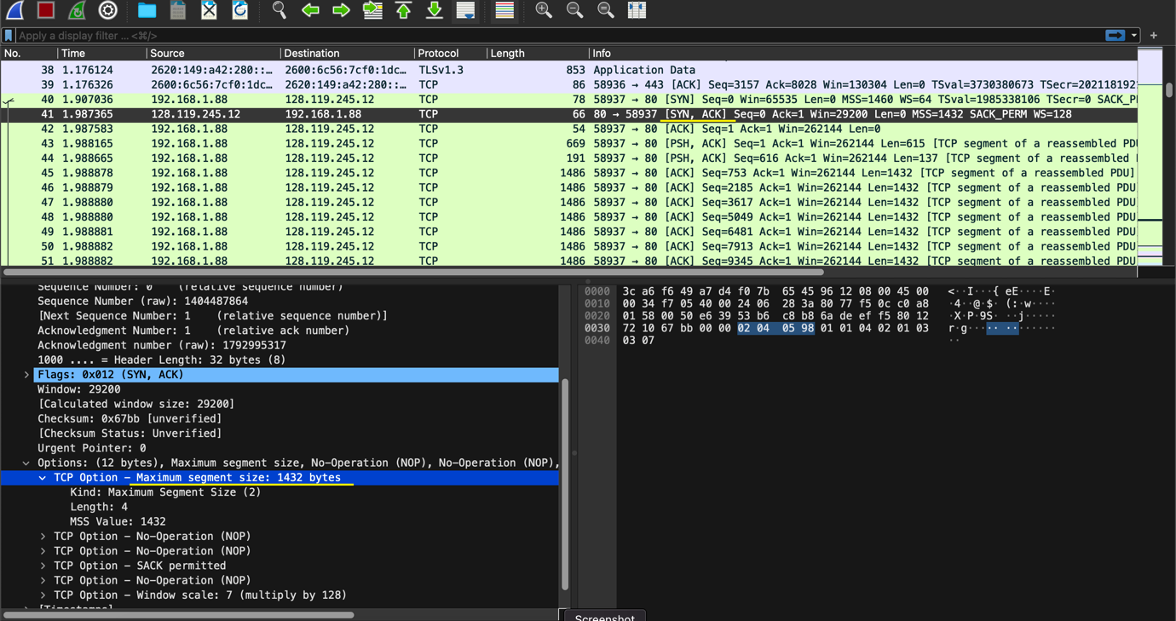

Question : 8

Frame no 41

Round trip time for the ACK received by the server is

**[The RTT to ACK the segment was: 0.080329000 seconds]**

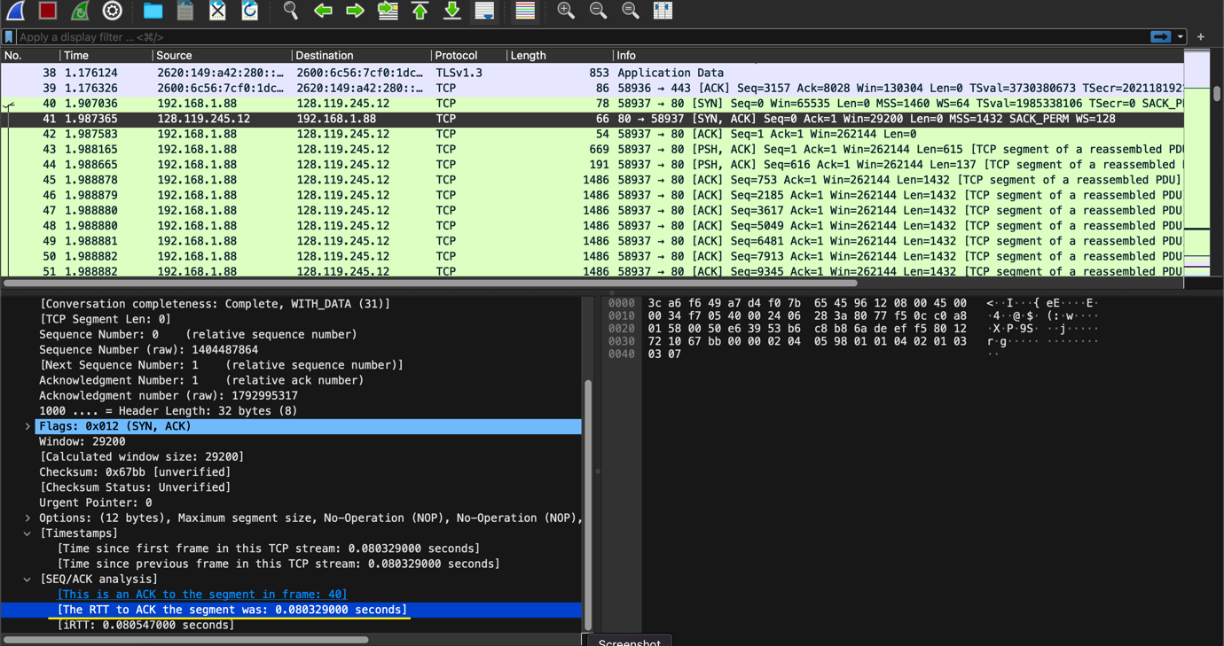

Question : 9

Frame no 43 is the first packet that is being sent here in my case reason is that we see the PSH in the info and the data field contains POST and since the packets(http) are carried over tcp .

[Calculated window size: 262144]

[Checksum Status: Unverified]

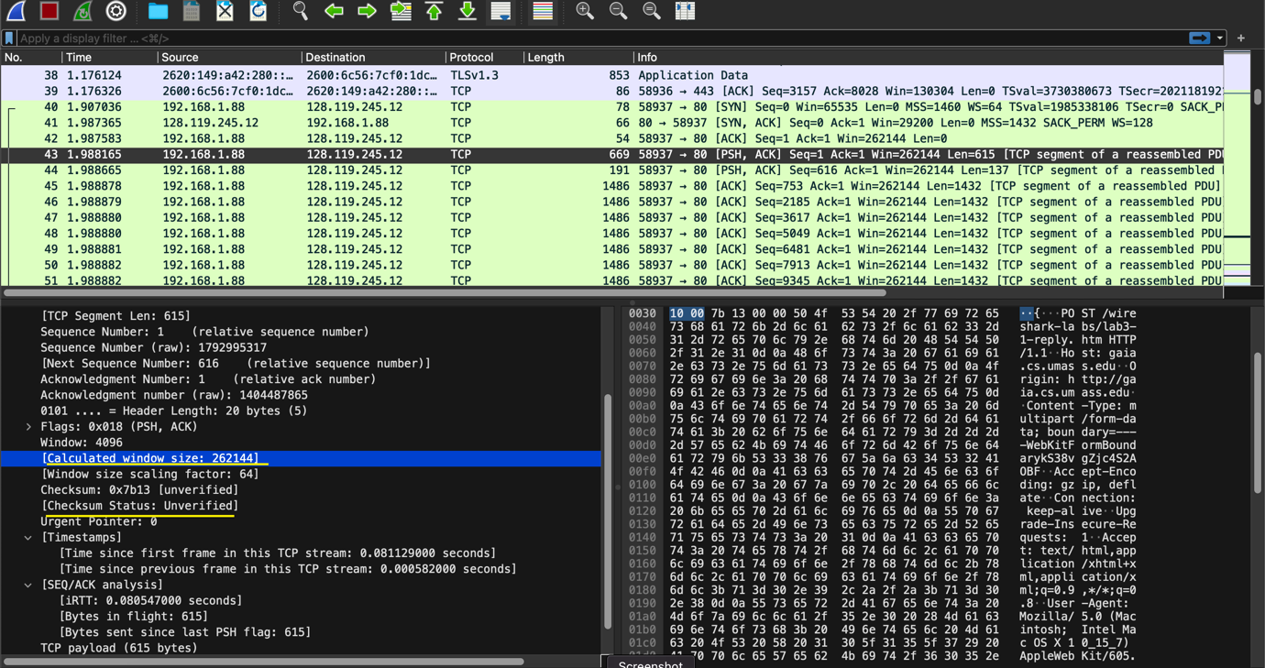

Question 10 :

Yes , in many frames we can see the push flag that is being set to 1 .

Significance of PUSH flag:

1. Enables for more efficient data transfer and a much more efficient communication.
2. It is highly required for the applications that require real time data delivery or a connection that deals with the low-latency communication.
3. The general aim behind the push flag is that it is used to tell the sender is sending the data receiver without any further ado and there will be no buffer filling in this scenario.
4. This flag means that the data is directly ‘pushed’ to the received one’s application layer immediately.
5. There could be two case where we could consider here
6. First case : Whether the first HTTP first packet push flag is set here
7. Second case : Any random HTTP packet’s push flag is set or not

First case :

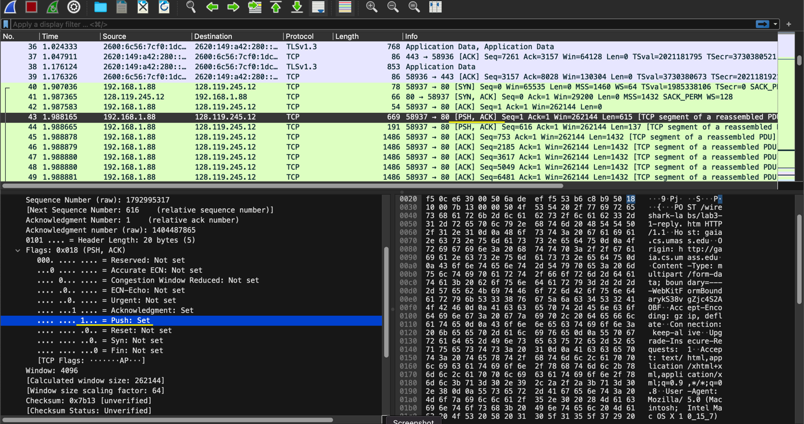

Second case : *

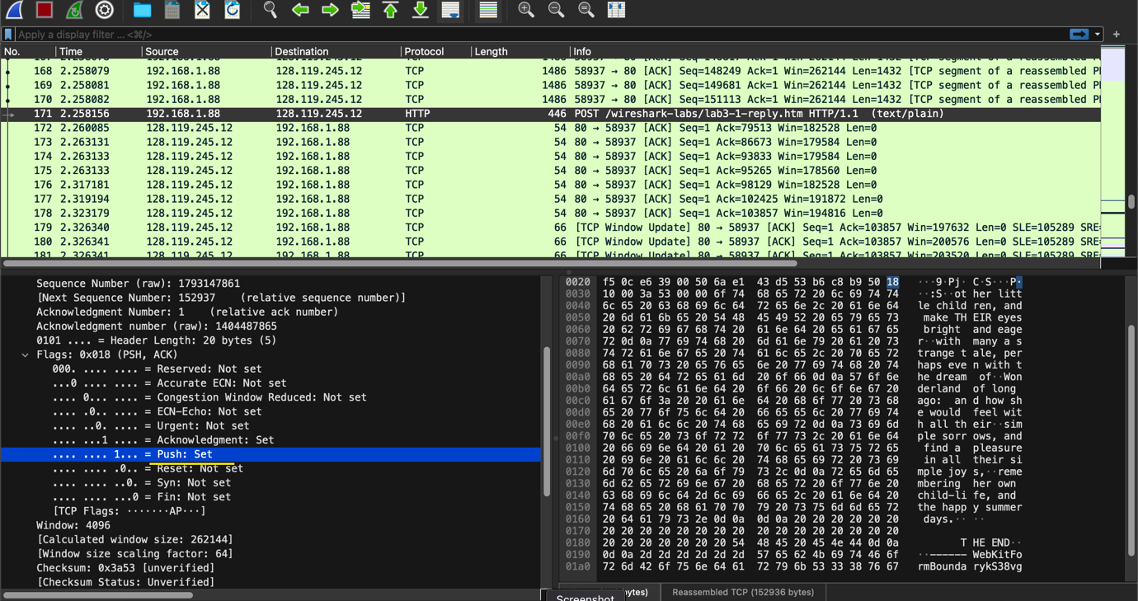

Question : 11

Font face = ="Arial, Helvetica, sans-serif" size="4"

Acknowledgment Number: 152937 (relative ack number)

Acknowledgment number (raw): 1793148253

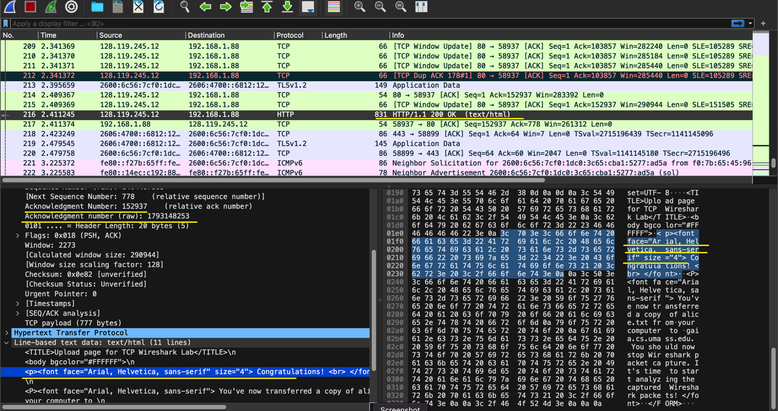

**Question 12**

The signals sent between sender and receiver, FIN flag is the signals termination of a connection . It means the connection is being closed for the frame.

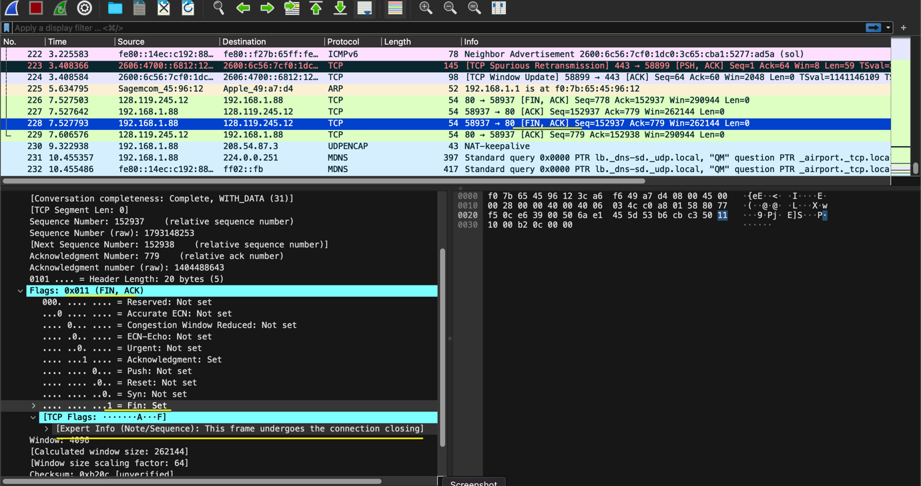

Question : 13

1. Here , the Server(umass.edu). sent the started {FIN,ACK} packet
2. Client has responded the connection closing from the server side
3. Then , the client choose to send the [FIN,ACK] to the server
4. Server responded it with an ACK.

So, server is the party that initiated the connection .

But , here the source server and the client can choose anytime to close the termination.

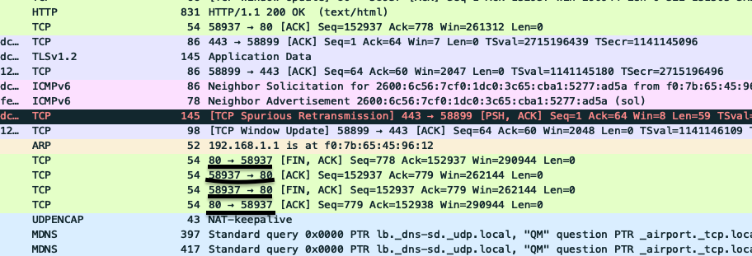

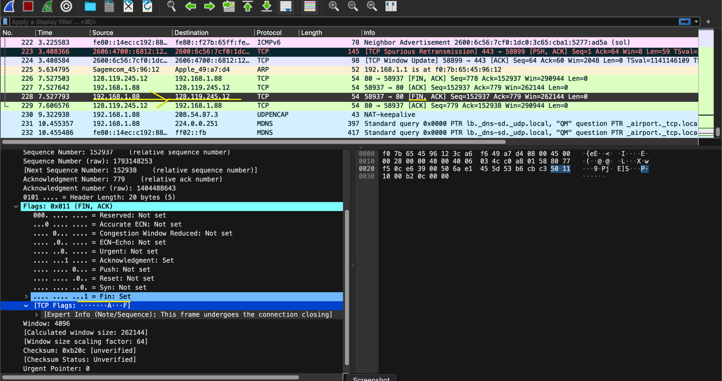

Question: 14

Here, I considered the ultimate last one, the one where tcp connection terminated ack is being transmitted.

Acknowledgment Number: 152938 (relative ack number)

Acknowledgment number (raw): 1793148254

